**CASE STUDY - CONTAINERIZATION USING DOCKER I**

Problem Statement: You work as a Devops Engineer in a leading Software Company.

You have been asked to Dockerize the applications on the production server. The company uses custom software, therefore there is no pre-built container which can be used.

Assume the following things:  
 1. Assume the software to be installed is apache

2. Use an Ubuntu container

The company wants the following things:

1. Push a container to DockerHub with the above config   
     
   2. The Developers will not be working with Docker, hence from their side you will just get the code.
2. Write a Dockerfile which could put the code in the custom image that you have built

Below are the docker images we have in this Ubuntu machine locally

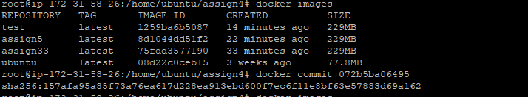

In order t push to remote repostitory, Commmiting the change user docker commit

